

NAMES REG NUMBER
JAYDEN C KAMONERE | R2211990H
MANATSA T MAKUVAZA | R229545Y

LEVEL : 4.1
MODULE : CONVERGED AND HYPERMEDIA PRODUCTION
PROGRAM : PRINT MEDIA AND DIGITAL TECHNOLOGIES

SPORT BEAT

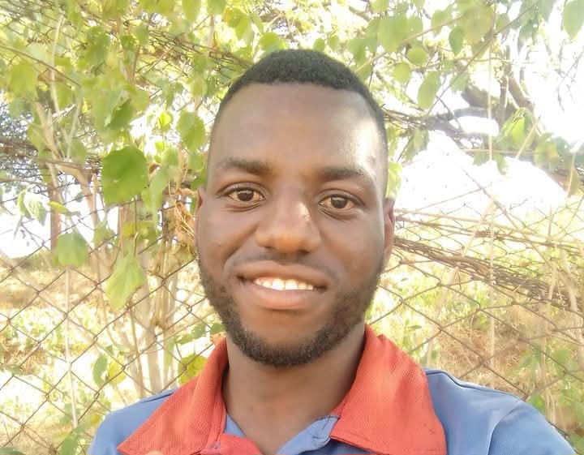 AKIM PHIRI born in Zvishavane Maglass loves football.

AKIM PHIRI born on 10 October 1999 and raised in the mining town of Zvishavane ,is a man whose life has been intertwined with the beautiful game of football. From an early age, Akim exhibited a natural affinity for the sport, which set the foundation for his future.
Akim is a 26 year old man who lives in Zvishavane Maglass standing at about 8 inches tall, Akim has an athletic build body, weighing 75 kilograms . His complexion is a rich, deep brown, typical of the Shona people of Zimbabwe.
Akim mannerisms reflect both confidence and humility. He carries himself with a quiet dignity, walking with measured steps and maintaining steady eye contact during conversations. Akim is the eldest of four siblings in his family. He is an always smiling person who carries himself with kindness and ability to help others. He enjoys wearing caps and bucket hats no matter its hot or cold. He is a God fearing person with his religion being Christianity and every Sunday he does nothing except going to church.
His father was a miner who worked in the asbestos mines that have long been central to the town’s economy, while his mother managed the household and occasionally sold perishable products at the Mandava market. Akim completed his primary at Shabanie Primary School in 2012 and his secondary at Mandava Secondary School in Zvishavane in 2017, where he excelled but because of his love for football he could not proceed further with education.
Raised in a modest household, Akim’s early life was shaped by strong family values, community support, and a relentless passion for football. His parents encouraged his dreams, understanding that sport could be a pathway to a better future.
Akim’s childhood was filled with moments of joy and challenge, but football was always his refuge and his driving force. “My parents always supported me on my dream of being a football player such that at the age of 5,they always bought me full soccer kit for me” ,he revealed . “I always enjoy wearing football jerseys because am into football that much, ”he added with a light smile.
“My favorite colour is red since l am a Liverpool fan” said Akim .He further indicated that for the mean time marriage is not in his mind ,because he wants to have everything in order before doing that huge step.
Akim’s football journey began at a young age when he joined a local youth club in Zvishavane. “At tender age l was approached by different clubs to play for them and that is the time l realized that l could make a living out of my talent” he reveals. His talent quickly became evident as he displayed remarkable speed, ball control, and tactical awareness on the pitch. As a teenager , he was an outstanding player in regional tournaments, earning admiration from coaches and peers alike.
His dedication to training was exemplary. “l would often be the first to arrive for sessions and the last to leave, pushing myself to improve every aspect of my game and coaches loved my football discipline. ”He had an ability to read the game, set the pace as a natural team player and a burgeoning leader.
“My hard work paid off when l was recruited by a prominent football club in Zvishavane’s Shabanie Mine FC and this was a significant milestone to play competitive and professional soccer. ” he says. He indicated that he works well under pressure ,goal scoring ,inspirational performances that helps his team to achieve victory.
Fate dealt Akim a harsh blow in one of critical match as he sustained a severe knee injury leading to both physically and emotionally denigration that nearly lead to his football career ending .
“l faced a long and painful process and l grappled with frustration, disappointment, and the fear that my football dreams might be over. Yet, through resilience and determination, l refused to let this setback define me,” he revealed.
Akim told the reporters how he later found a to remain glued to the football world that opened a different chapter .The period of recovery allowed his time for introspection and realized that while his days as a player might be limited, the love for football remained undiminished .He began to explore other ways to stay connected to the game, resulting in him turning into coaching at the age of 25.He has husky voice that act instrumental to instructing players when coaching them.
Apart from football ,he is running a shop which sells laptops and phones and when he is not coaching, he usually spend most of his time at a shop which in Mandava. He is a smiling person because the jobs that he does requires him to be open to people.
Akim indicates how he learnt leadership from other important people in the world of football .“l sought mentorship from experienced coaches and this phase was transformative, as l discovered a new purpose to share my knowledge, inspire others, and contribute to the sport in a different but equally meaningful way,” he says
His ultimate goal is to help elevate Zvishavane football . His journey as a talented player was disturbed by an injury. Akim Phiri stands as a beacon of hope and a testament to the transformative power of football.

